BIT 4107 – Mobile Application Development
ENHANCED PROFESSIONAL STUDENT LOGBOOK
Student Name: Issa Hafif
Admission Number: BIT/2024/52570
School/Faculty: School of Computing and Informatics
Programme: Bachelor of Science in Information Technology
Academic Year: 2026/2027
Semester: May/August
Lecturer: Mr. Nyoro
Phone Number: 0710408477

Contents
WEEK 1: Introduction to Mobile Application Development 2
Installing the development tools 2
1.Android studio 2
2.Visual Studio Code 2
Configuring development environment 2
1.Android studio (SDK) 2
2.Flutter 4
Creating the first mobile app 6
Personal Reflection 8
Week 2: Programming Languages and Frameworks 9
Flutter project (Mini Student Management App) 9
1.Frameworks(figma) 9
2.Screenshots (Actual App) 10
Personal Reflection 11
Week 3: User Interface (UI) Development 12
Building a complete UI 12
1.Frameworks (figma) 12
2.Screenshots (Actual App) 14
Database Intergration(SQLite) 17
Firebase 18
Personal Reflection 19

WEEK 1: Introduction to Mobile Application Development

Installing the development tools

1.Android studio
From the website (https://developer.android.com/studio), download.
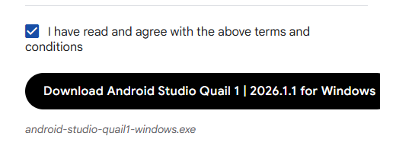
Figure 1

2.Visual Studio Code
From the website(https://code.visualstudio.com), download.
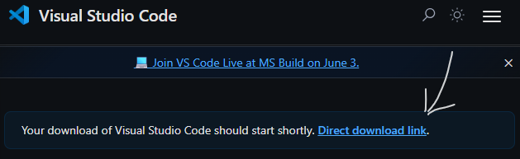
Figure 2

Configuring development environment

1.Android studio (SDK)
SDK Platform
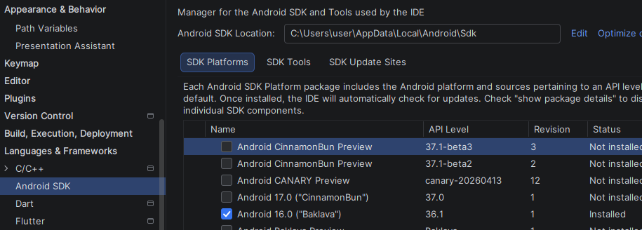
Figure 3

SDK tools
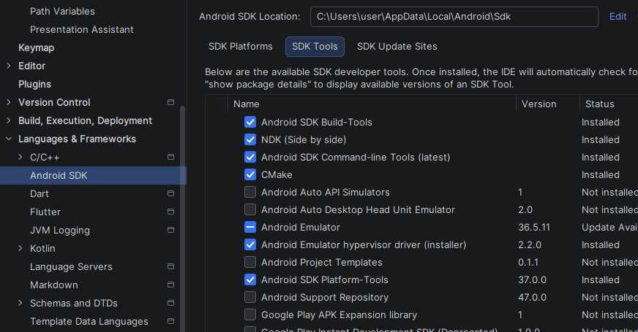
Figure 4
Emulator
From device manager, add a virtual device (create a virtual device), select a device (e.g., Pixel 2) and download.
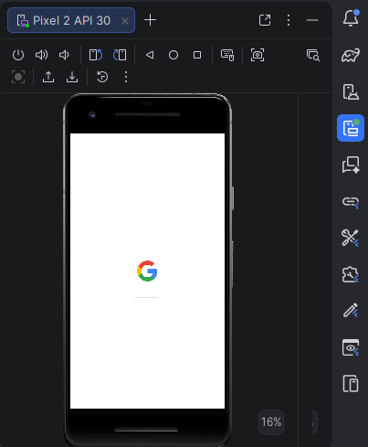
Figure 5

2.Flutter
Installing flutter, dart, GitHub Copilot extensions.
-Flutter comes with dart.
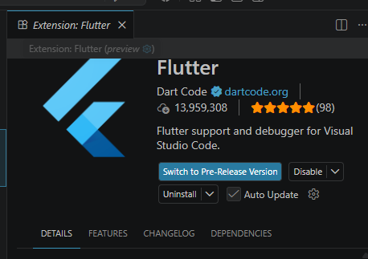
Figure 6

-Since GitHub Copilot is deprecated, we will use the chat
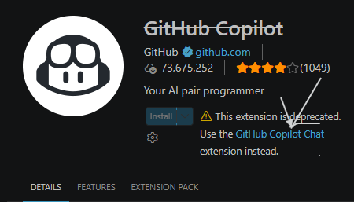
Figure 7

Creating the first mobile app
- Open the terminal in vs code and run “flutter create firstflutterapp”
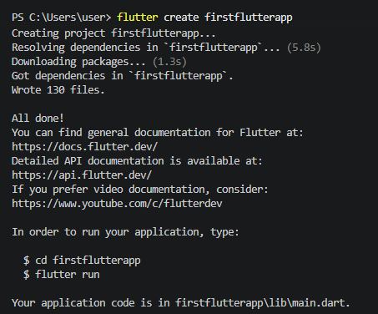
Figure 8
- Then move into firstflutterapp (“cd firstflutterapp”), then open in vs code (“code .”)
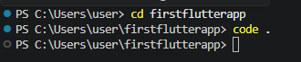
Figure 9
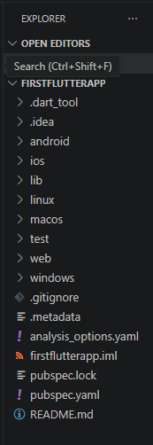
Figure 10
3.Changing the app title, background color and font size (after that we run “flutter run”)
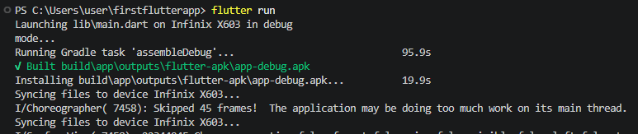
Figure 11
Before | After
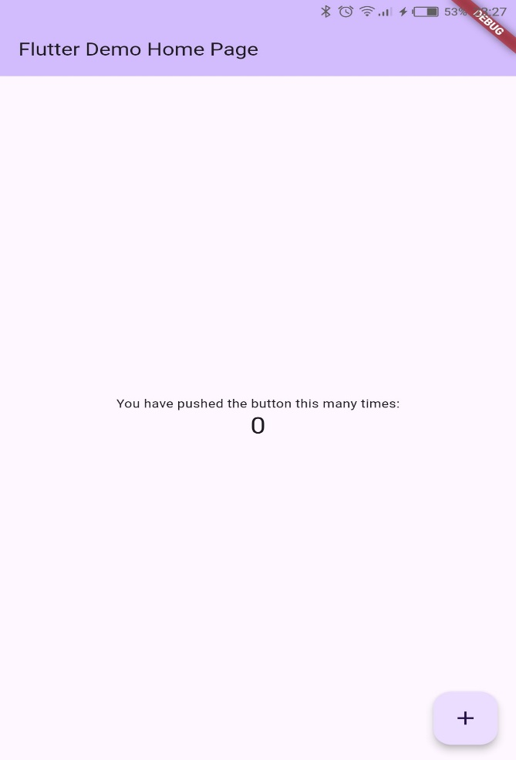  Figure 12 | 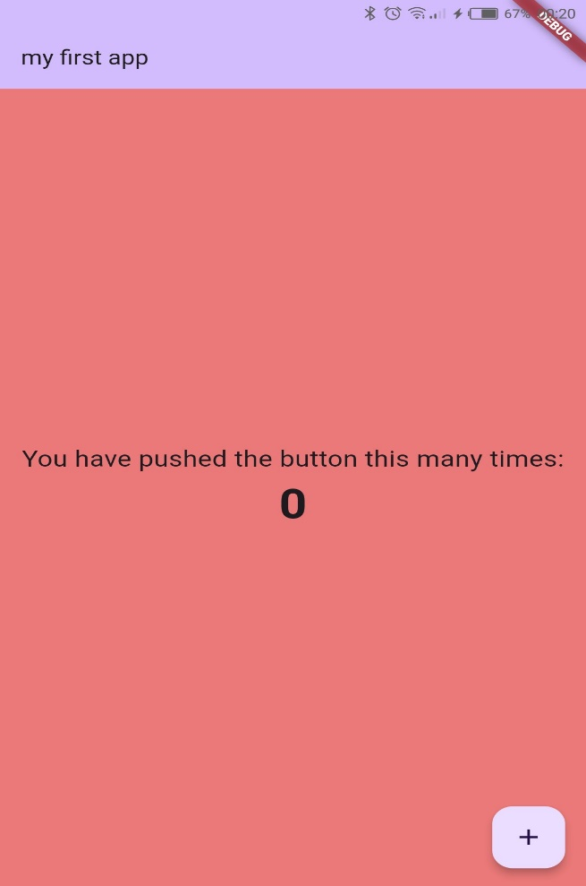  Figure 13

Personal Reflection
This introduction helped me understand the basics of mobile application development and the tools used in the industry. Although setting up the development environment was challenging at first, I learned how to solve configuration issues and successfully created my first Flutter application.

Week 2: Programming Languages and Frameworks

Flutter project (Mini Student Management App)

1.Frameworks(figma)
Registration page | Dashboard
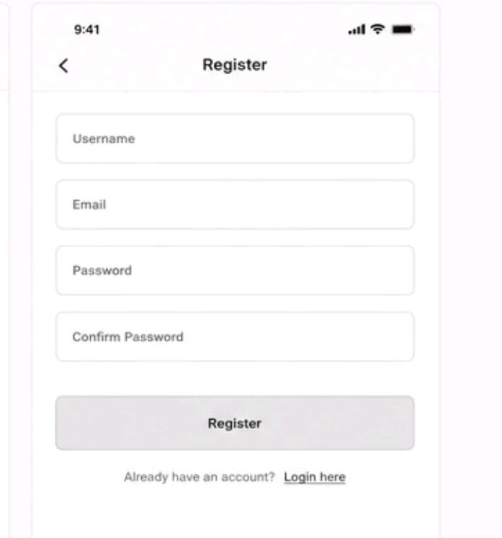  Figure 14 | 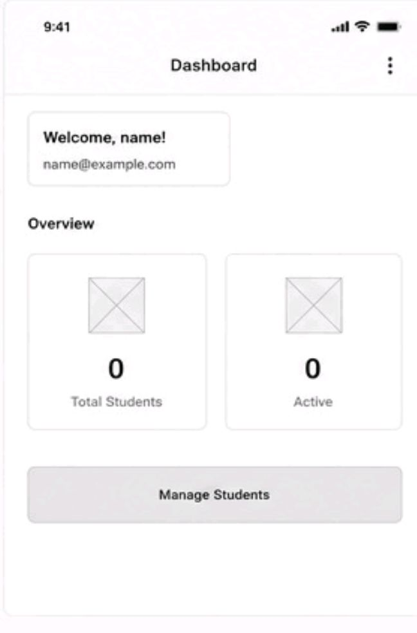  Figure 15

2.Screenshots (Actual App)
Login page | Registration page
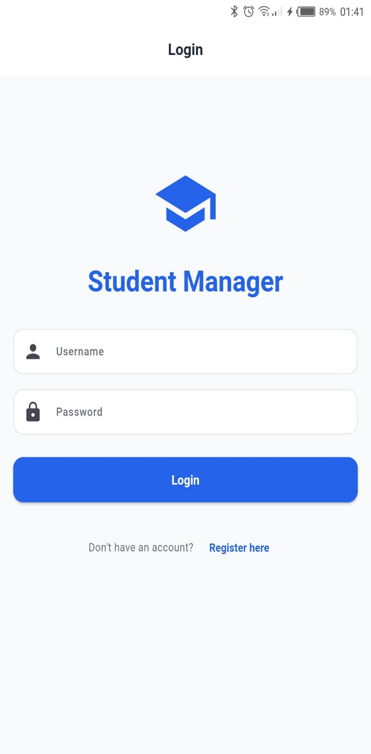  Figure 16 | 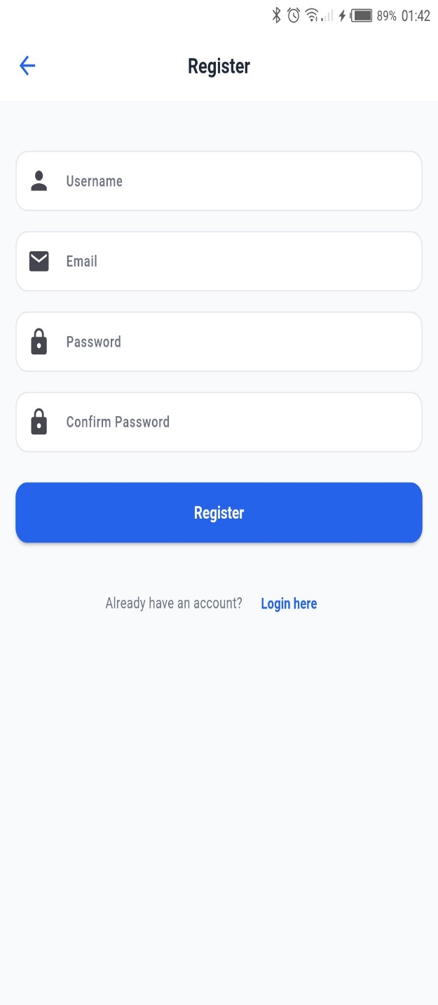  Figure 17

Dashboard
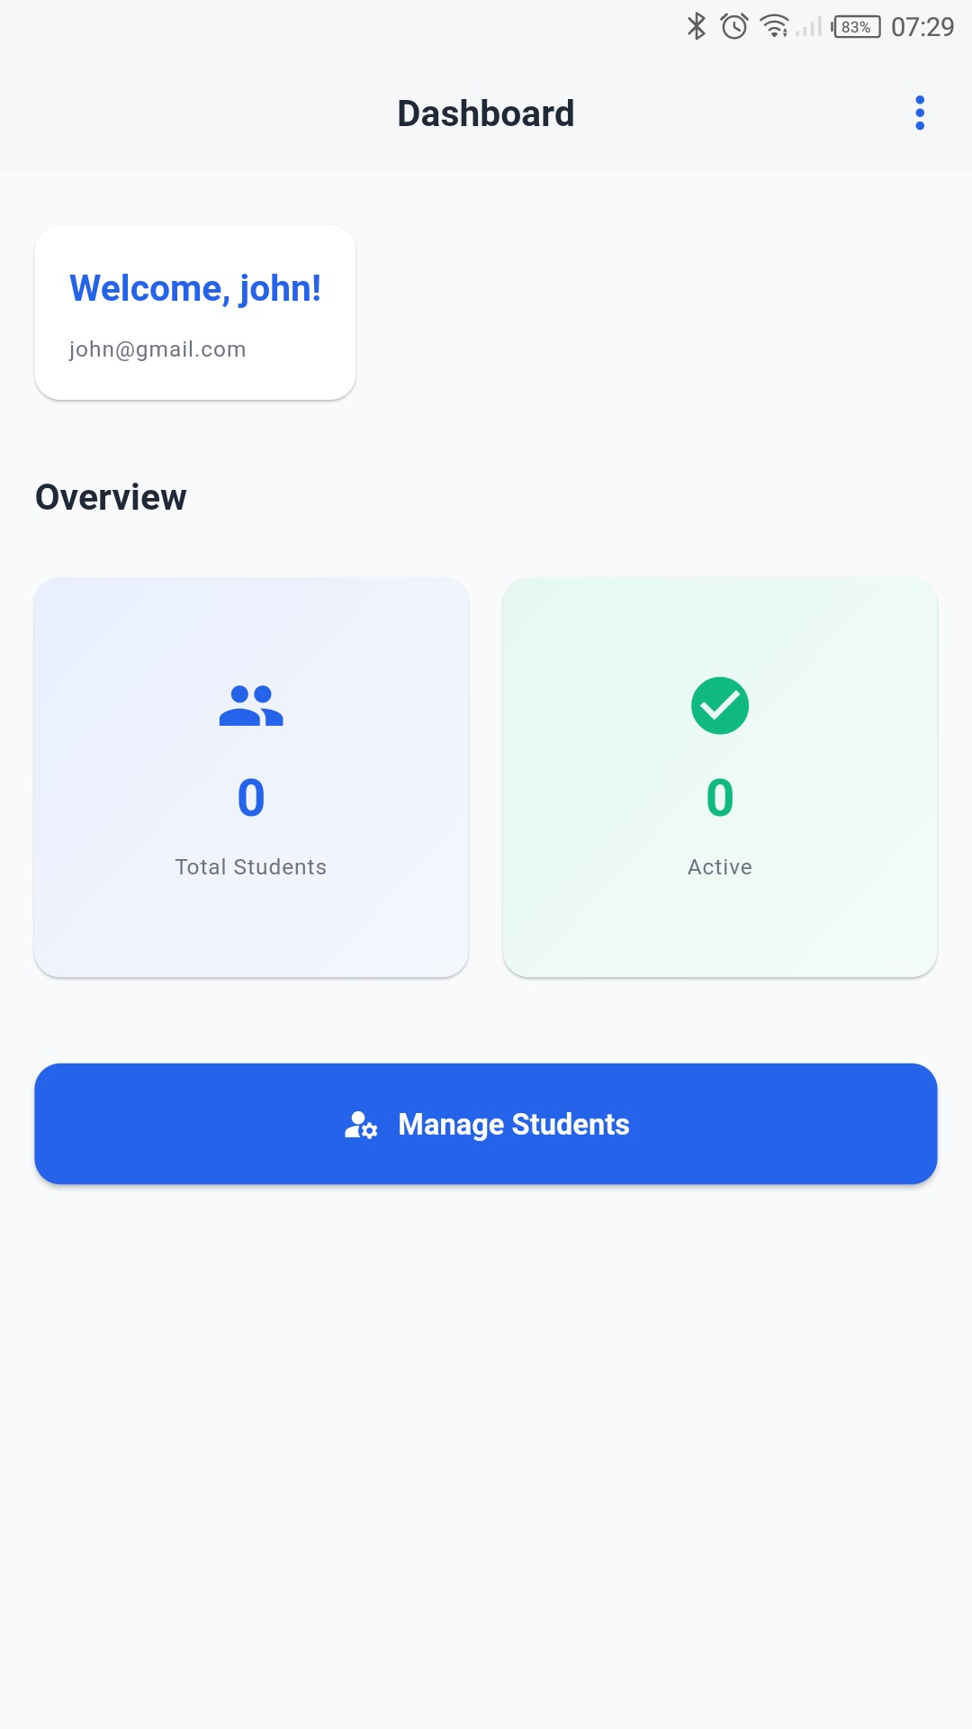
Figure 18

Personal Reflection
I enjoyed learning different programming concepts and applying them in Flutter. Building screens and working with user interface components improved my coding skills. I also gained a better understanding of how databases and APIs can be integrated into mobile applications.

Week 3: User Interface (UI) Development

Building a complete UI

1.Frameworks (figma)
Create an account in figma and start building wireframes.
Login page | Dashboard
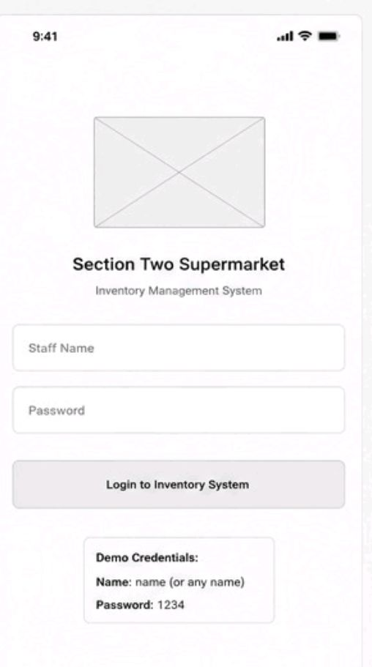  Figure 19 | 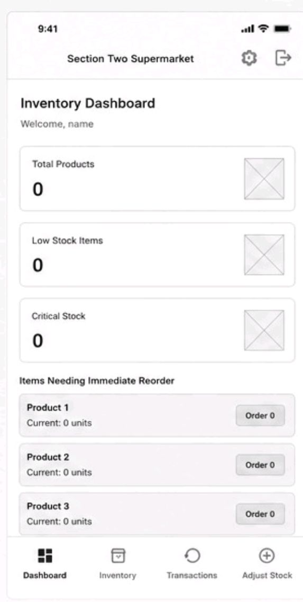  Figure 20
Inventory | Transactions
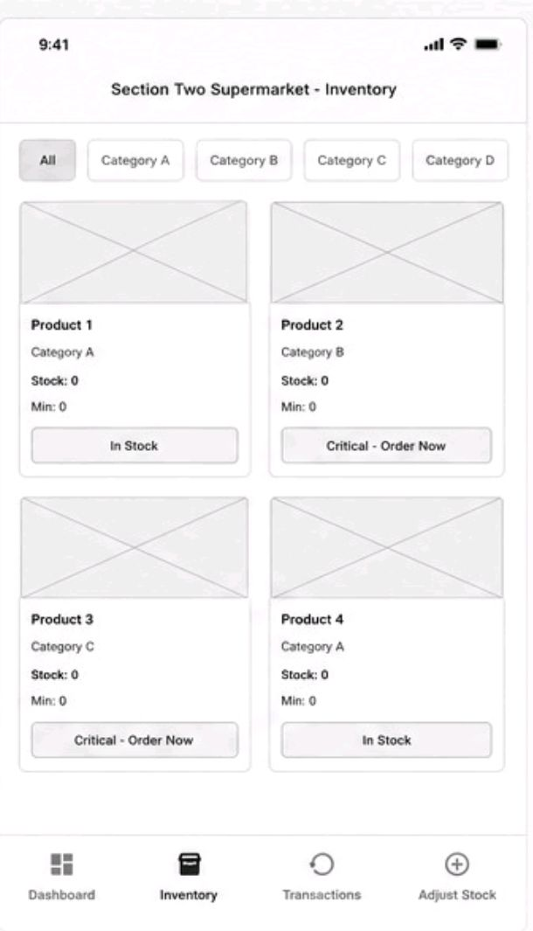  Figure 21 | 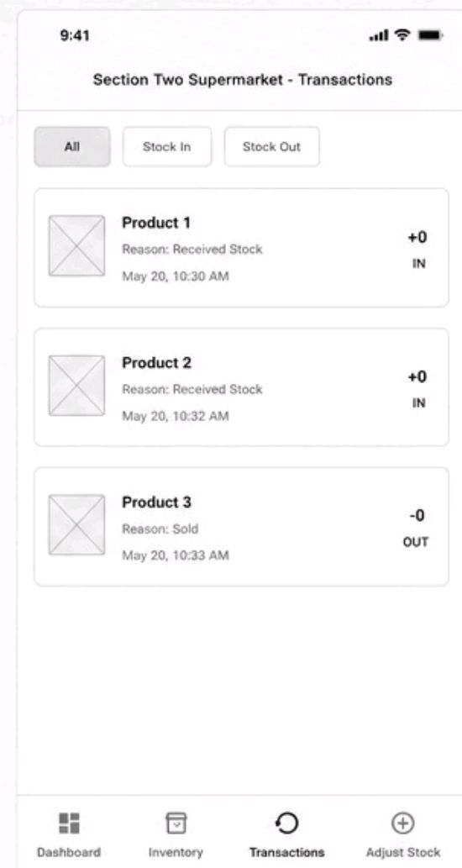  Figure 22

2.Screenshots (Actual App)
Login page | Dashboard
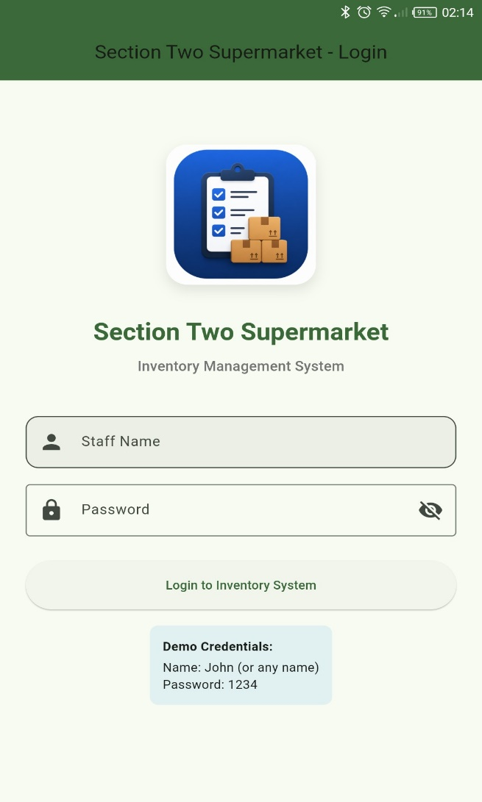  Figure 23 | 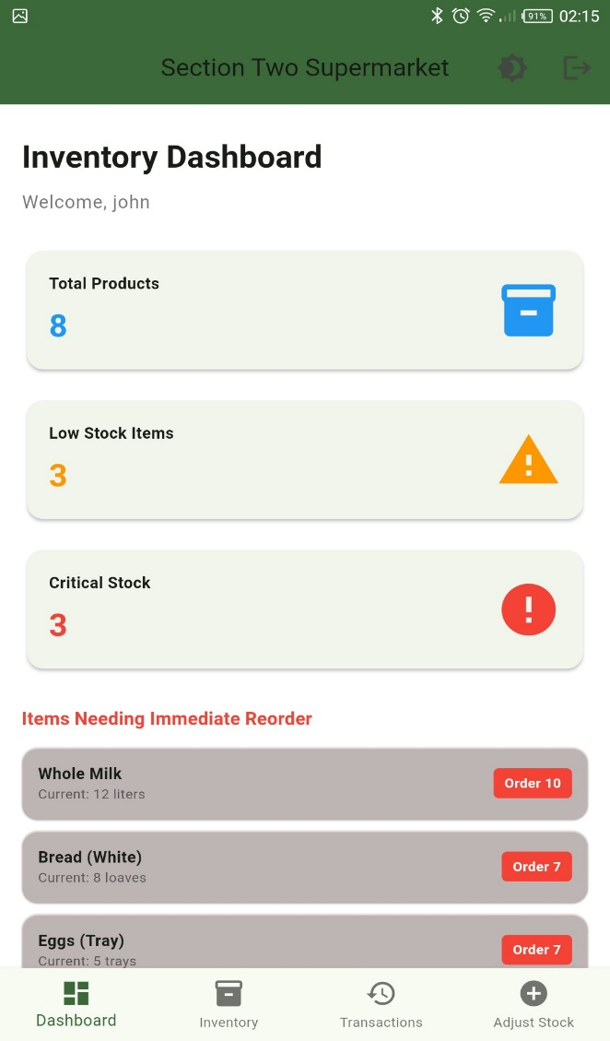  Figure 24

Inventory | Transactions
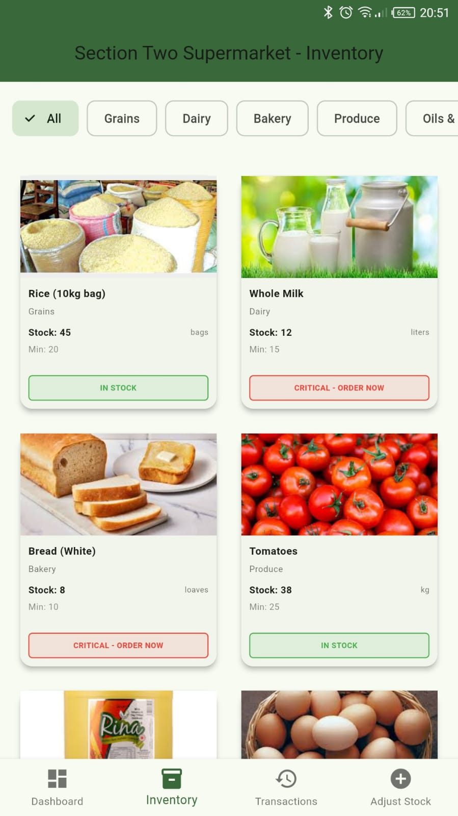  Figure 25 | 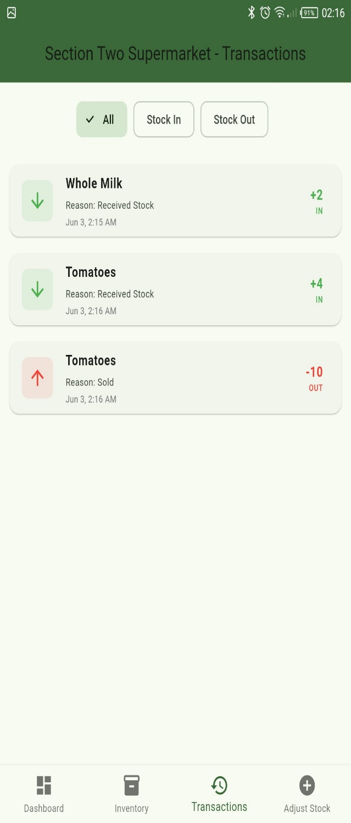  Figure 26
Stock adjustment
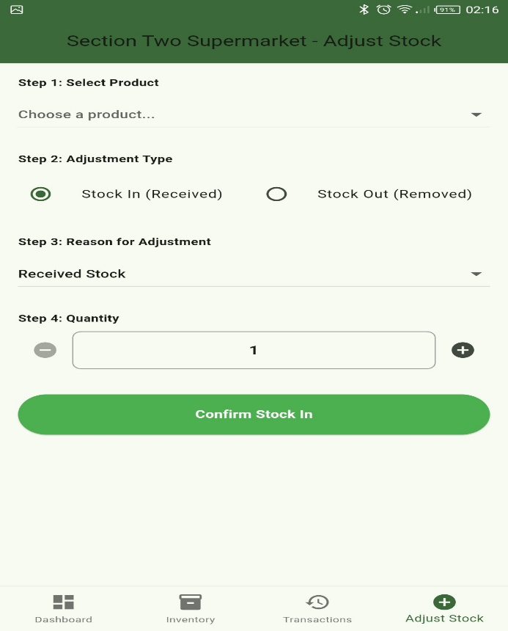
Figure 27

Database Intergration(SQLite)
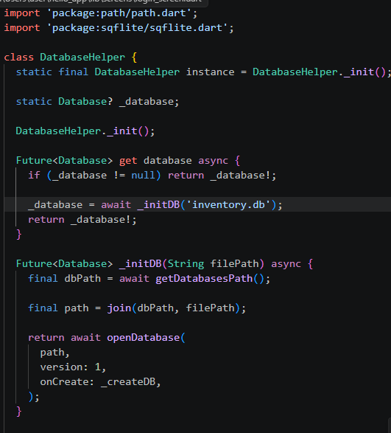
Figure 28

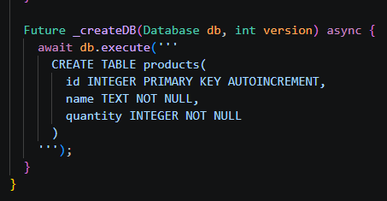
Figure 29

Firebase
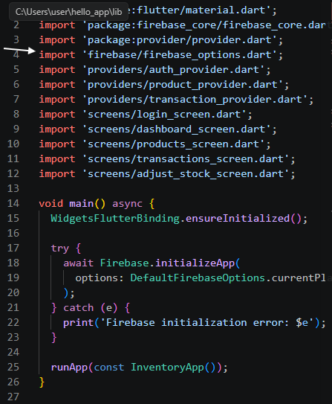
Figure 30
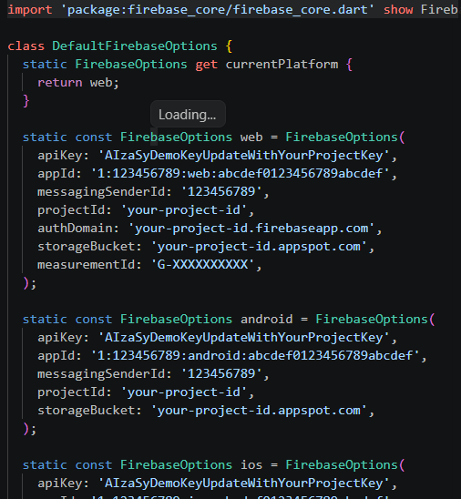
Figure 31

Personal Reflection
I’m able to know the importance of a good UI/UX design. Creating wireframes and turning them into working interfaces helped me appreciate the planning involved in app development. I also improved my skills in designing responsive and user-friendly mobile applications.

